VESTA IP Speaker User Manual

**Content**

1. Overview 3
2. Web Configuration 3
   1. Status 4
   2. Basic 4
      1. Date/ Time 4
      2. Network 5
      3. Network Advanced 6
   3. ONVIF 7
   4. SIP Account 7
      1. SIP Set 7
      2. SIP Advanced 8
   5. Audio 9
      1. Codec 9
      2. Speaker 9
      3. MIC 10
   6. Media File 11
   7. Alarm 12
      1. Alarm In (IO connection) 12
      2. HTTP URL 12
   8. Schedule 13
   9. RTP Multicast 14
   10. Firewall 15
       1. Firewall Rules 15
       2. Automatic Defense 16
   11. Auto Provision 16
       1. DHCP option 16
       2. PnP 17
       3. Static Provisioning Server 17
   12. System 18
       1. Maintain 18
       2. Auto Reboot 18
       3. Security 18
3. IPTool Configuration 19

## Overview

VESTA IP speaker have different shape and design to fulfill the installation in indoor and outdoor environment, they are well compatible with SIP & ONVIF protocol that are able to be used in VoIP and security field. Up to 10 RTP multicast address enable to arrange different paging solutions, alarm in and HTTP URL are able to combine with alarm system. Pre-recorded message and schedule broadcasting to meet various paging demands. The 48K OPUS Audio Codec enables excellent sound quality, to make announcement, play background music, security alarm in school, factory and hospital, etc.

## Web Configuration

Web configuration includes complete function setting, after the device and PC are connected to a same network, type the device’s IP address in a web browser, the default IP address is [192.168.5.200,](http://192.168.5.200/) then log in with defaulted username and password as below, and there are different language options.

Username: admin Password: tm1234

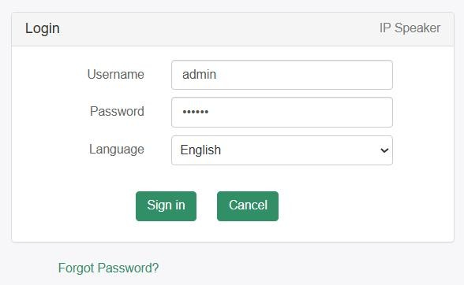

### Status

Show out device time, firmware version, free space and SIP accounts status, and also MAC, IP address and gateway etc.

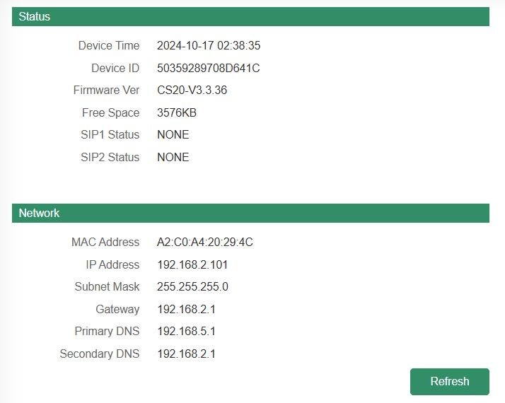

### Basic

### Date/ Time

Two update modes for time：NTP and local time.

* + - * 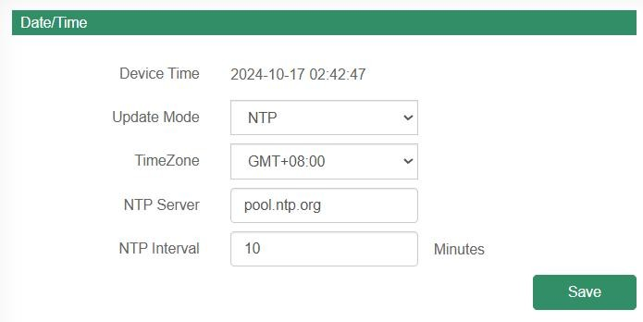NTP: set time zone, NTP sever and interval, then save the configuration.
      * 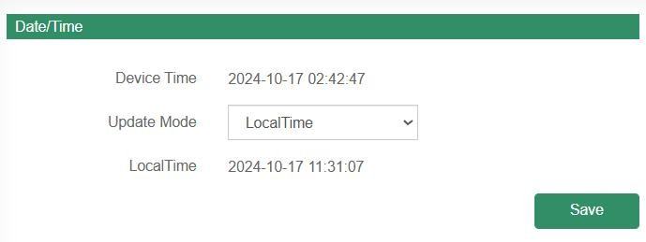Local time, follow the PC time.

### Network

* + - * DHCP, IP address will be created automatically by DHCP server
      * Status IP address, it could set up as required of IP Address, Subnet Mask, Gateway, Primary DNS, and Secondary DNS.

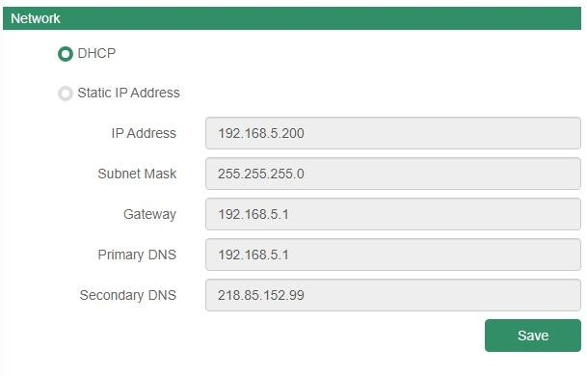

### Network Advanced

Set Http or Https or both, and the ports of Http, Https and RTSP. And VlAN configure, able for VLAN ID, VLAN IP, VLAN Netmask, and VLAN Gateway setting.

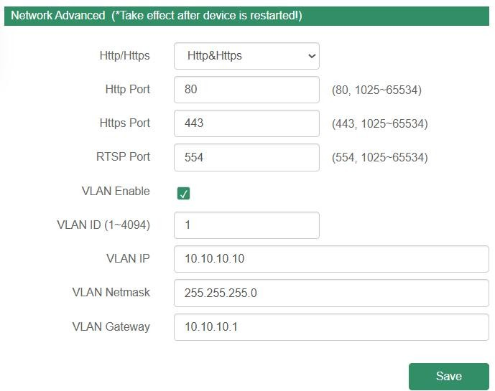

### ONVIF

* Select Enable ONVIF, then the device is able to be searched by ONVIF VMS, the password and user name is same like IP speaker log in user name and password.
* WAN NAT, do ports forward on router to ensure that data can be transmitted correctly between the server and the public Internet, then come to speaker web and turn on the option **WAN NAT**, insert the IP address, HTTP Port and RTSP Port.

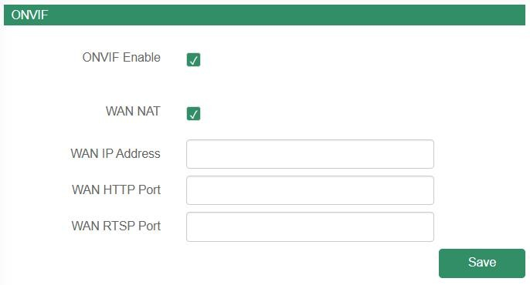

### SIP Account

### SIP Set

Each speaker has two SIP accounts, put SIP server extension messages into the blanks and save the configuration, then you can check if it registers successfully or not.

|  |  |
| --- | --- |
| User Name | User account, provided by SIP server |
| Auth ID | SIP service subscriber's ID used for authentication. |
| Password | Account password provided by SIP server |
| Display Name | SIP service subscriber's name |
| Server Host | SIP server address |
| Server Port | SIP port, default to be 5060 |
| Outbound Proxy | It is used to process signals and help data streams to go through  firewall or NAT if there have. |
| Expire Time | Set the expire time of registered account information |
| Ringing Tone | 5 system ringtones and 10 users upload media files |
| Auto Answer | answer immediately and answer delay when a calling income |
| Incoming Notify | Put an input URL, when a incoming call ringing, URL take effect, include to play HTTP audio stream |

|  |  |
| --- | --- |
| Answer Notify | Put an input URL, when a incoming call answered, URL take effect,  include to play HTTP audio stream |

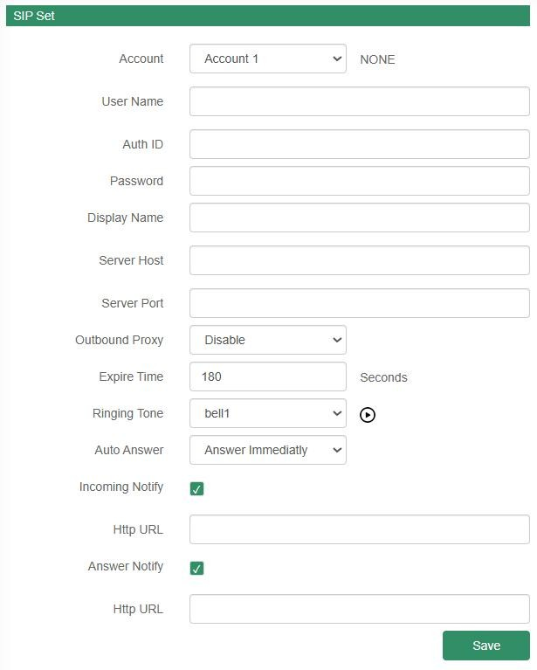

### SIP Advanced

Now IP speakers support to work under transport protocols of UDP, TCP and TLS, with the encryption of SRTP option.

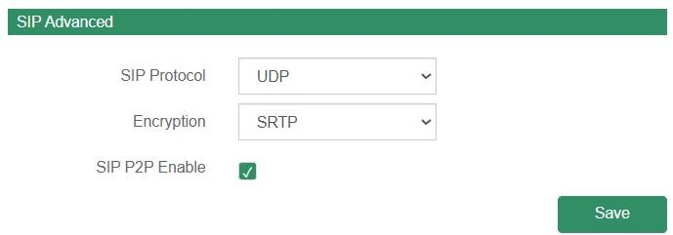Then if want to support SIP P2P (Peer-to-peer SIP), then click to make it work. If it takes place on a local network, all that’s needed are the SIP addresses of the user agents. A typical SIP address in this case would be SIP:<local IP>, like sip:192.168.5.200.

### Audio

### Codec

Under Audio, select at least one audio codec with the desired audio quality, there are four options.

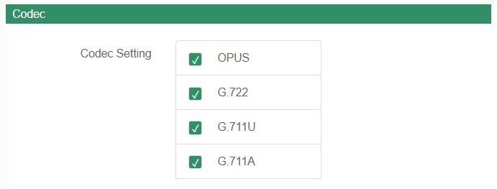

### Speaker

* + - * Volume: Speaker out volume
      * Amp Auto OFF: It’s set defaulted YES, to turn of the build in amplifier if do not play audio.
      * Jitter buffer: Make the audio playing more stable.
      * HPF: high pass filter, it is to filter the frequency under 150HZ.
      * NR: noise reduction, it is able to reduce the noise from audio input to improve sound quality when enable, it is calculated and simulated from the Chip.

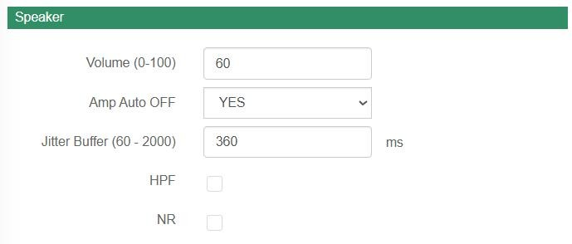

### MIC

* + - * Gain: There are four different gain level from none to high.
      * Volume: Build in MIC out volume
      * AEC: Acoustic Echo Cancellation
      * AGC: Automatic Gain Control
      * HPF: high pass filter, it is to filter the frequency under 150HZ.
      * NR: noise reduction, there are 3 level to reduce Premeter noise from speaker Mic side for listen. It is calculated and simulated from the Chip.

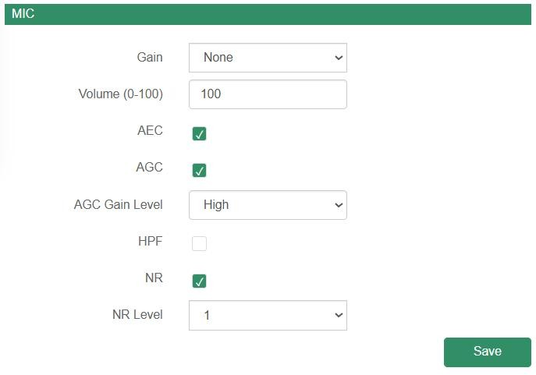

### Media File

Click to listen in PC, and click to listen in speaker side.

* System File

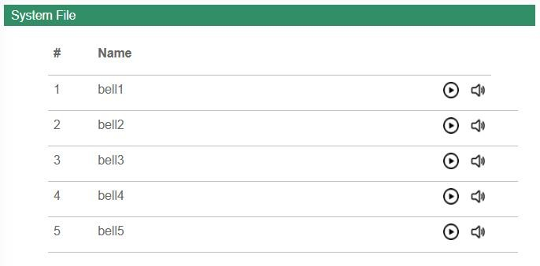Five system audio clips

* User file

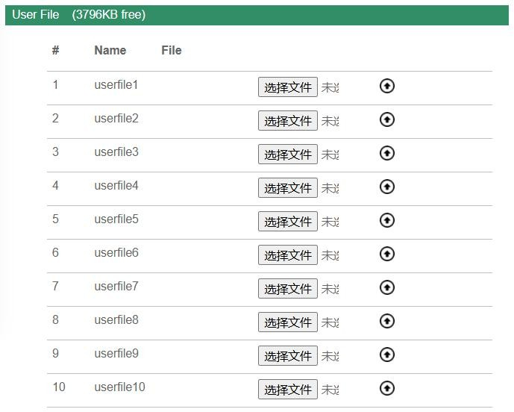10 audio clips upload bases on customers' demands, the free space is about 3800kb.

### Alarm

Two kind of alarm trigger, one is connected to speaker alarm in IO connector and the other one is HTTP API.

### Alarm In (IO connection)

* + - * File Enable: play pre-recorded audio
      * Sip Enable: enable SIP extension and SIP P2P call
      * Http Stream Enable: play HTTP audio stream, like <http://listen.livestreamingservice.com/181-greatoldies_128k.mp3>

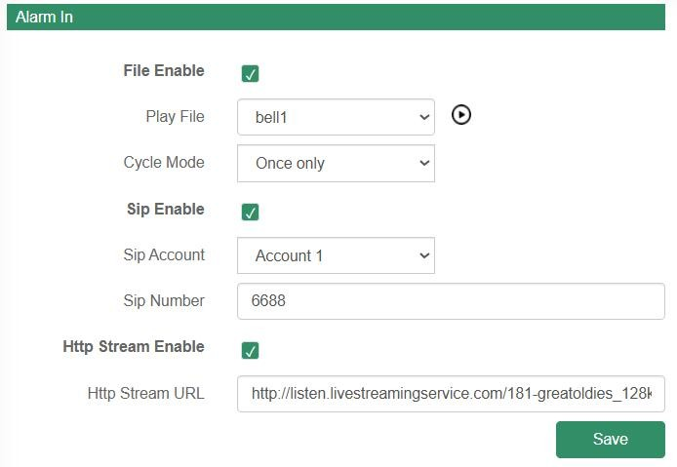

### HTTP URL

1. Enable Play URL Enable
2. Speaker will be able to receive supported HTTP URL

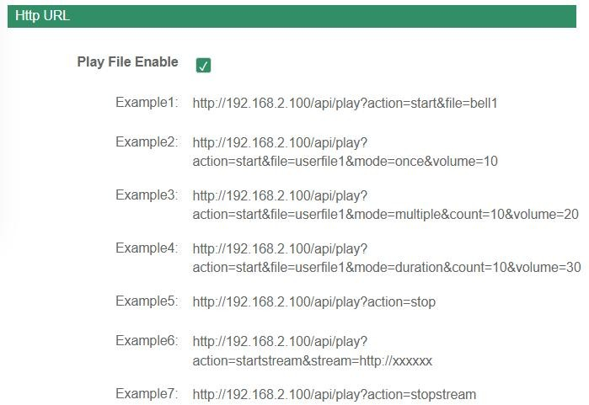

### Schedule

It is widely use in school, factory and office, make a regular bell, announcement and alarm, support 10 schedule set up.

* Enable the Schedule Enable
* Schedule Name
* Loop Type: Once, Daily and weekly
* Action Time
* Action Type: Start or Stop
* Play File: Pre-recorded audio clips
* Cycle Mode
* Http Stream URL: play HTTP audio stream, like <http://listen.livestreamingservice.com/181-greatoldies_128k.mp3>

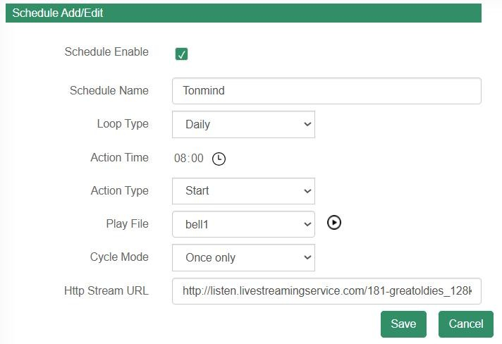

### RTP Multicast

Support 10 RTP addresses, please note that: port numbers do not use continuous numbers when setting the same RTP addresses. Use discontinuous numbers. eg:

239.255.1.2:8000，239.255.0.1:8001，239.255.0.1:8002（×）

* + - 1. :8000，239.255.0.1:8002，239.255.0.1:8004 (√)
         * Multicast address range: 224.0.0.0-239.255.255.
         * Ports range: 1024-65536
         * Use IP Tool, Audio Manager, PA Lite and PA Pro to do RTP multicast.

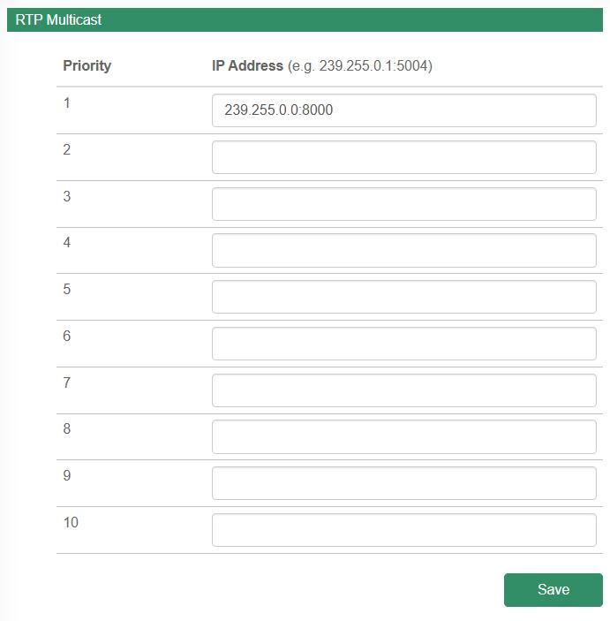

### Firewall

### Firewall Rules

* + - * Name
      * Rule Type: IP address or MAC
      * Protocol: ALL or TCP, UDP
      * IP Address or Mac: like 192.168.5.200
      * Net Mask:
      * Action: Accept or not.

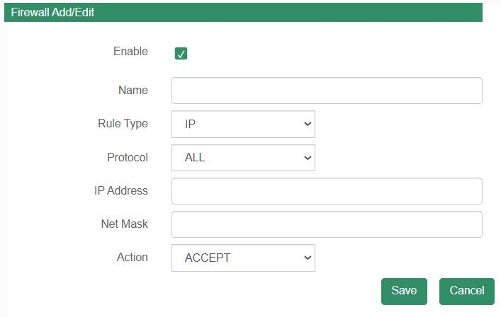

### Automatic Defense

Set to protect from the TCP and UDP port or ICMP.

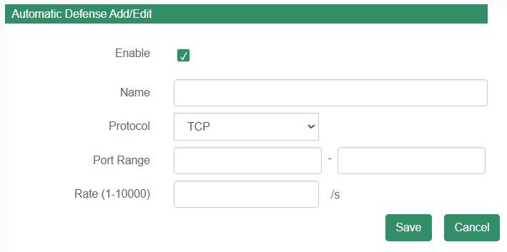

### Auto Provision

Three ways to set up IP speaker auto provision, it is MAC-based configuration provisioning, support third-party server storing configuration files of DHCP, PnP, TFTP, FTP and HTTP.

### DHCP option

set up a DHCP server first and then choose the option code, there three choices: option66, option43, Custom option, then follow the way to set the routine of configure file and run DHCP server.

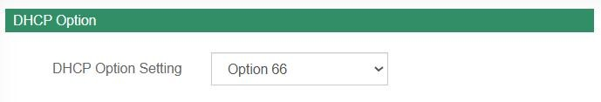

### PnP

Set up a PNP server, then follow the way to set the routine of configure file and run PNP server.

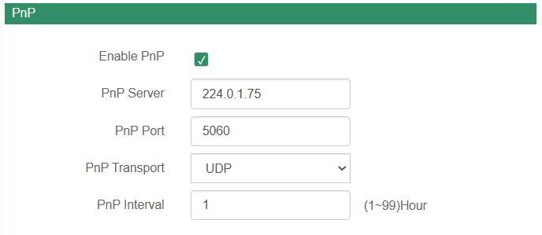

### Static Provisioning Server

Supports three kinds of protocol: TFTP, FTP and HTTP. Prepare a TFTP, FTP and HTTP server, and set up server address and the saving path of auto provision file, if the server needs authentication information, set up and remember the username and password.

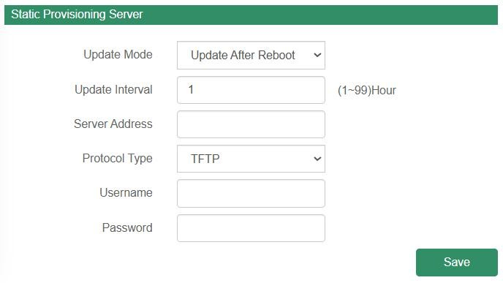

### System

### Maintain

* + - * Log: speaker running situation record
      * Reboot
      * Reset
      * Upgrade

How to upgrade IP Speaker firmware version in web interface?

1. Select the latest version firmware: xxx-bin.
2. Click upgrade, it would require about 20s to finish process.
3. Back to speaker login web interface.

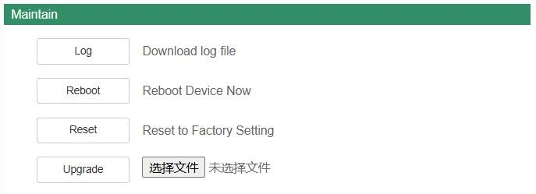

### Auto Reboot

Set to reboot as desired time.

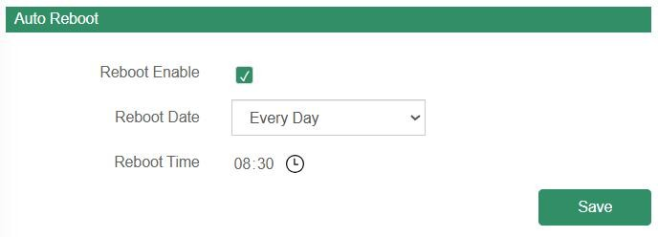

### Security

Set a new user name and password, save the configuration and restart login.

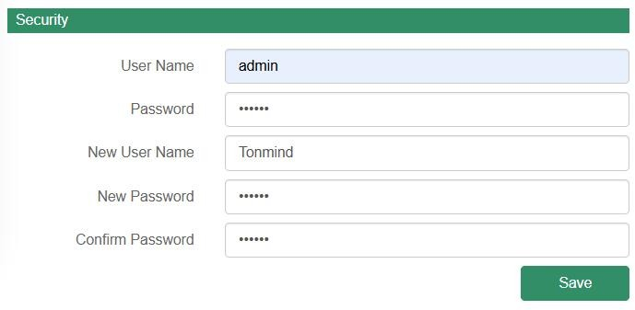

# IPTool Configuration

Apart from Web configuration, IPTool is the other option that configure quickly basic information such as SIP account setting, volume setting, RTP Multicast setting, upgrade. Please follow below steps.

1. Download IPTool
2. Run IPTool, select correct networking from “Network”, and then “Search” the devices and do setting.

